# **ASSIGNMENTS**

# Name: SATHIYAPRIYA P

# NM-ID:377566AB231843590A74E817D80E070A

# Brand Name: Wisdy Education

# Assignment 1:Blog Creation

Link: <https://misdyeducation.blogspot.com/2023/10/education-is-one-thing-no-one-can-take.html>

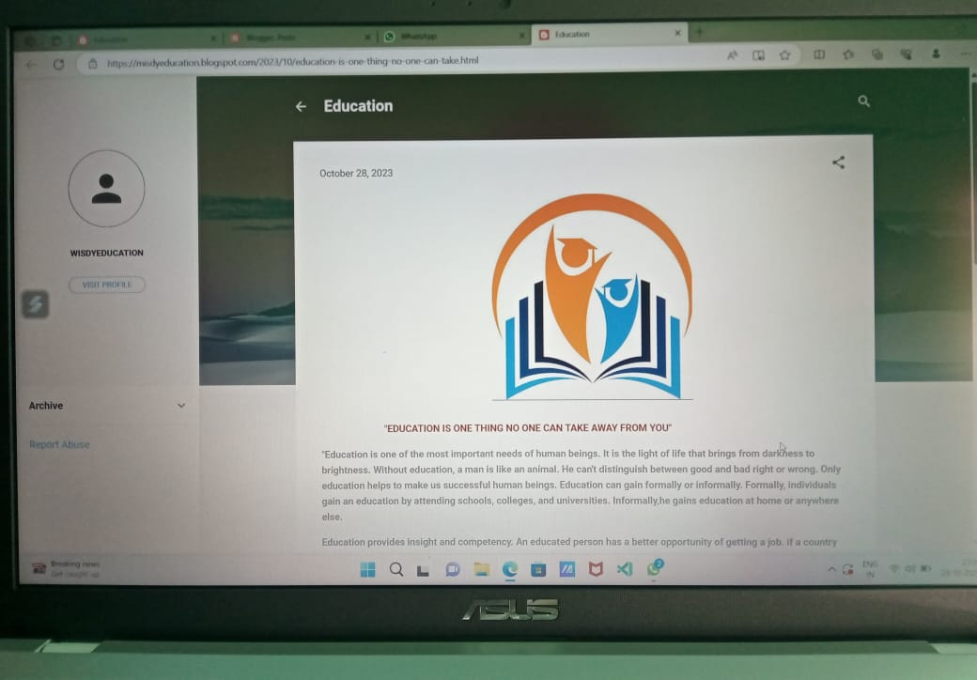

Assignment 2: Facebook Business Page Creation

Link: <https://m.facebook.com/story.php?story_fbid=pfbid0umpc7aCMo9aMoPv46auKYxw2kRNn6pfkdZEfzfq5x1oyqqfMdkpNSELGybb3DGHwl&id=61550544487413&mibextid=Nif5oz>

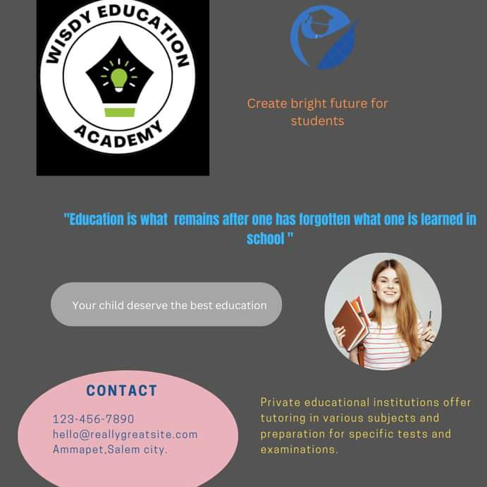

Assignment 3: Poster Creation

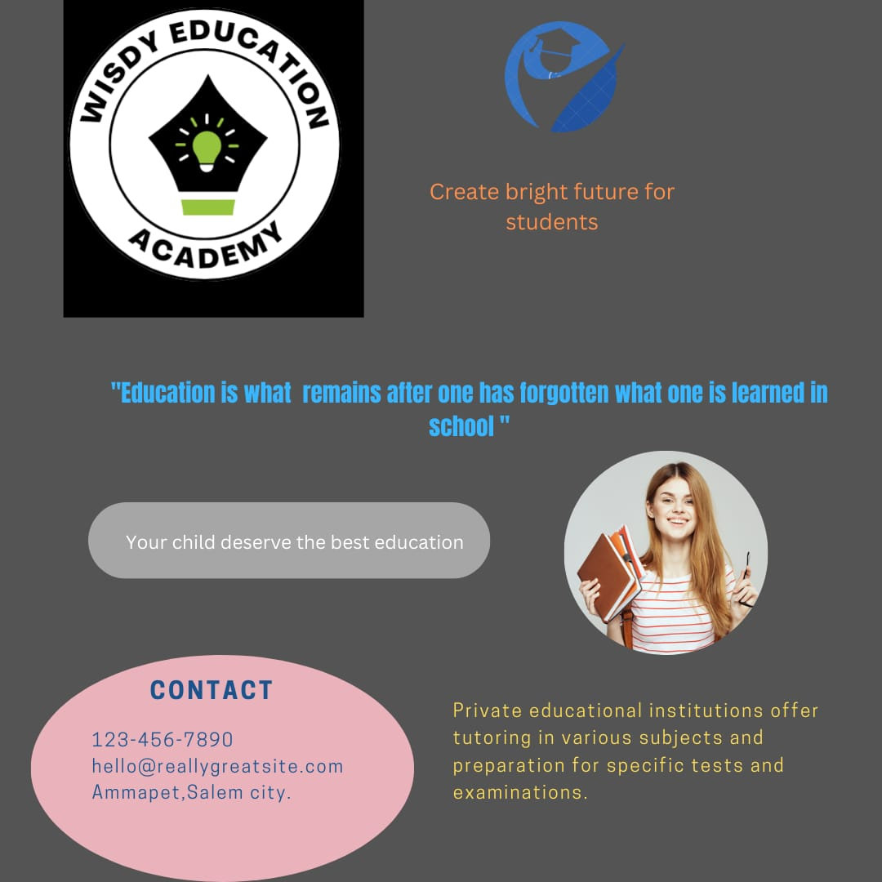

Assignment 4:News Letter Creation

